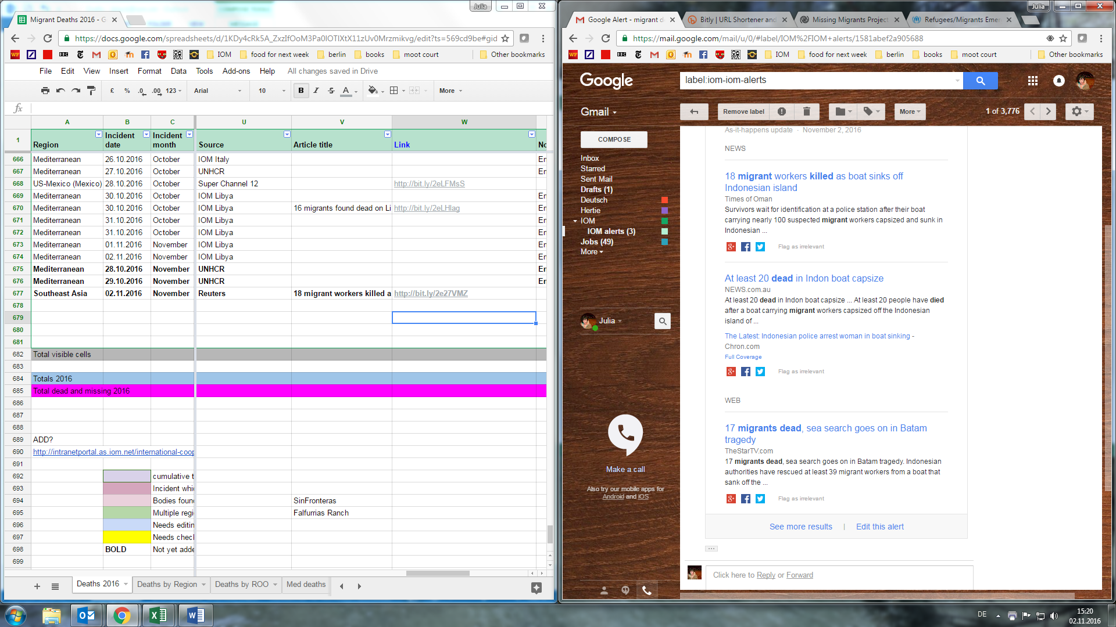

useful – refers to specific incident

useful – refers to specific incident

useful – refers to specific incident

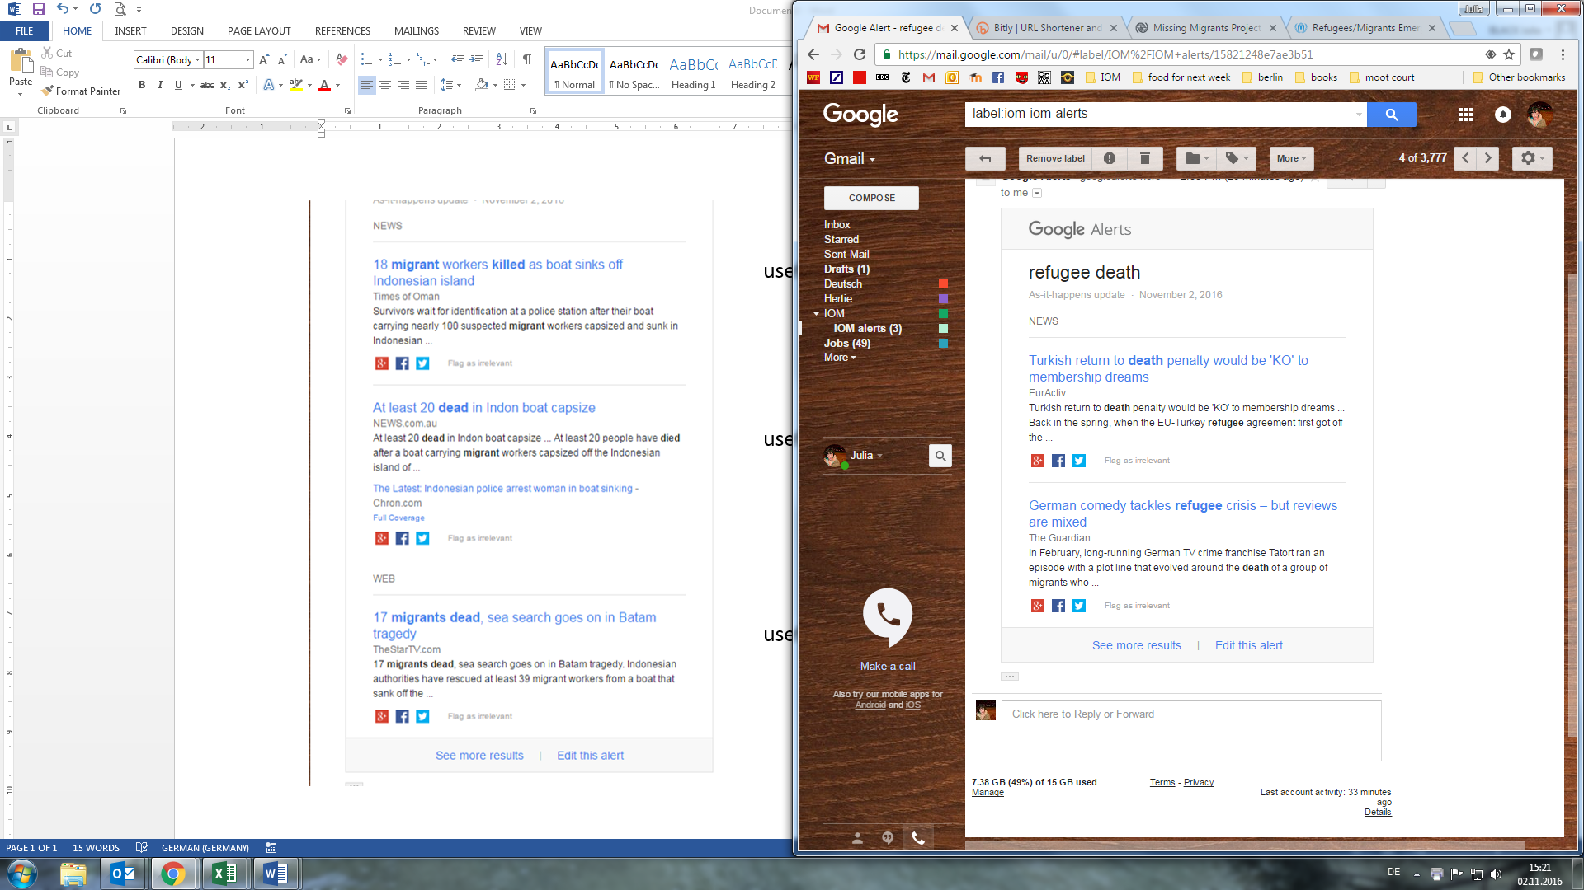

not useful – irrelevant content

not useful – irrelevant content

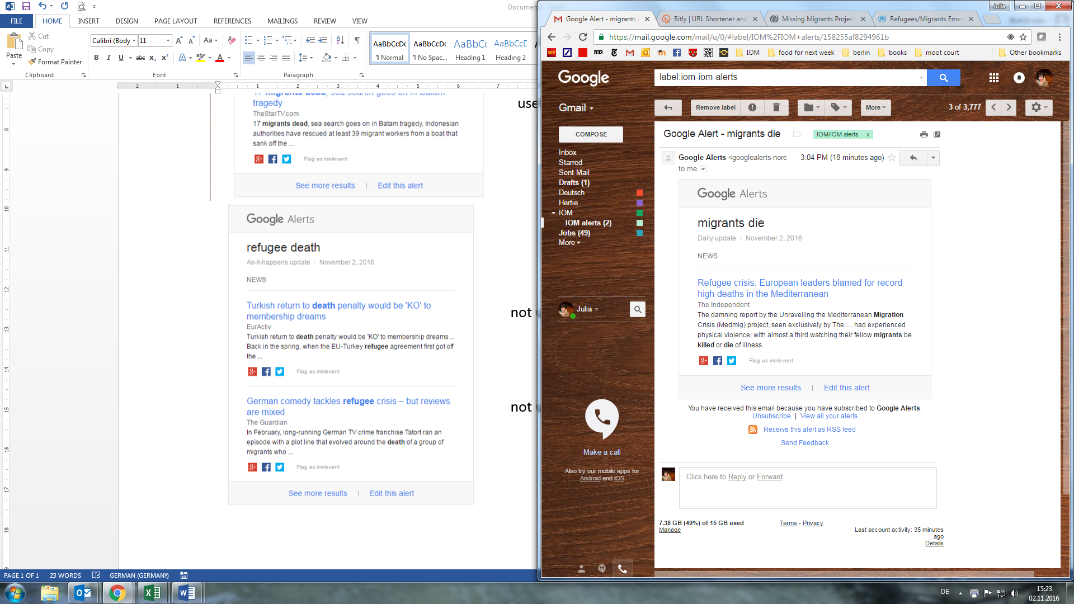

not useful – does not refer to specific incident

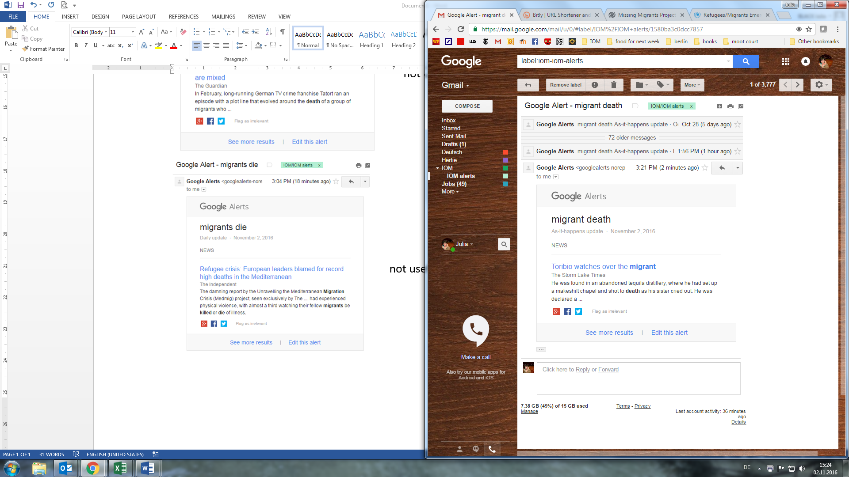

not useful – irrelevant content

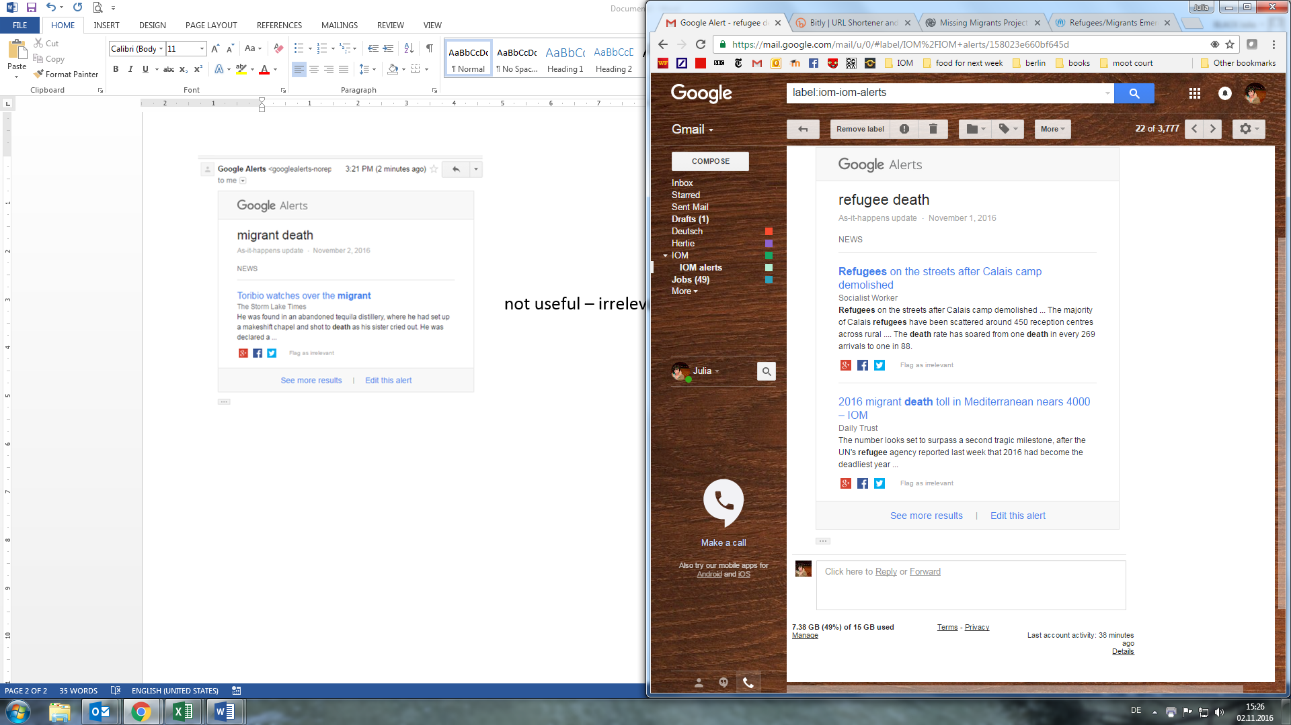

not useful – does not refer to specific incident

not useful – does not refer to specific incident

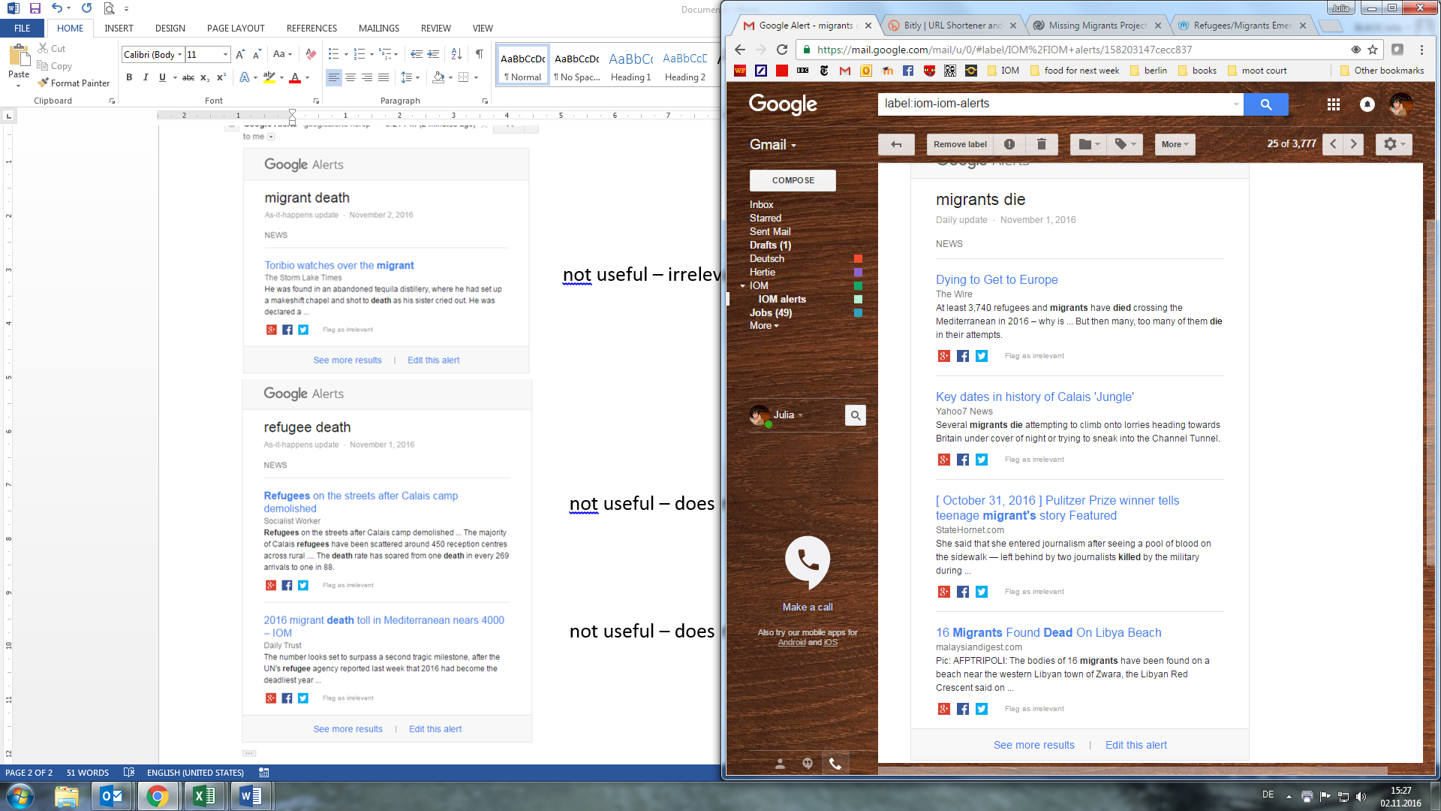

not useful – does not refer to specific incident

not useful – does not refer to specific incident

not useful – irrelevant content

useful – refers to specific incident



semi-useful – refers to specific incident with, but less than ideal as it does not include link to article

NEXT PAGE CONTAINS GRAPHIC PHOTOS, APOLOGIES



useful – refers to specific incident, link to news article with more information

semi-useful – refers to specific incident, but does not include any details or link

useful – refers to specific incident, links to article with more details